# CS 255 System Design Document Template

This template lays out all the different sections that you need to complete for Project Two. Each section has guidance to prompt your thinking. You will need to continually reference the interview transcript as you work to make sure that you are addressing your client’s needs. There is no required length for the final document. Instead the goal is to complete each section based on what your client’s needs are. Remove this note when you are finished, and replace all bracketed text with the relevant information.

## UML Diagrams

### UML Use Case Diagram

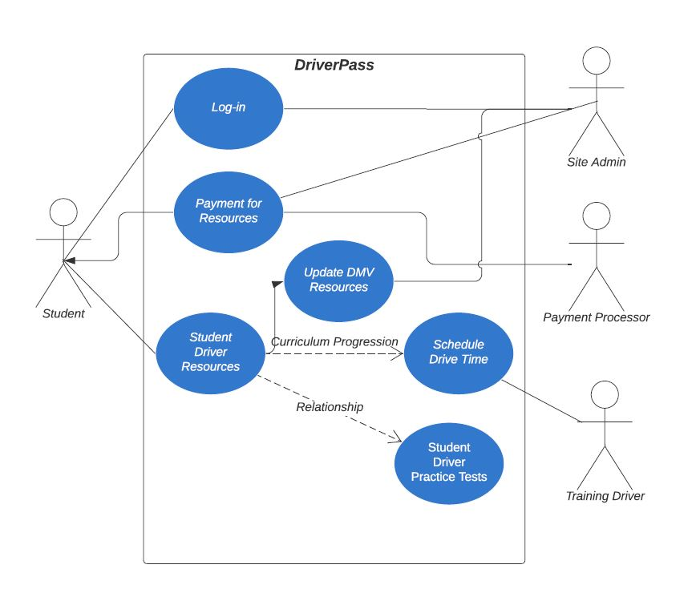

### UML Activity Diagrams

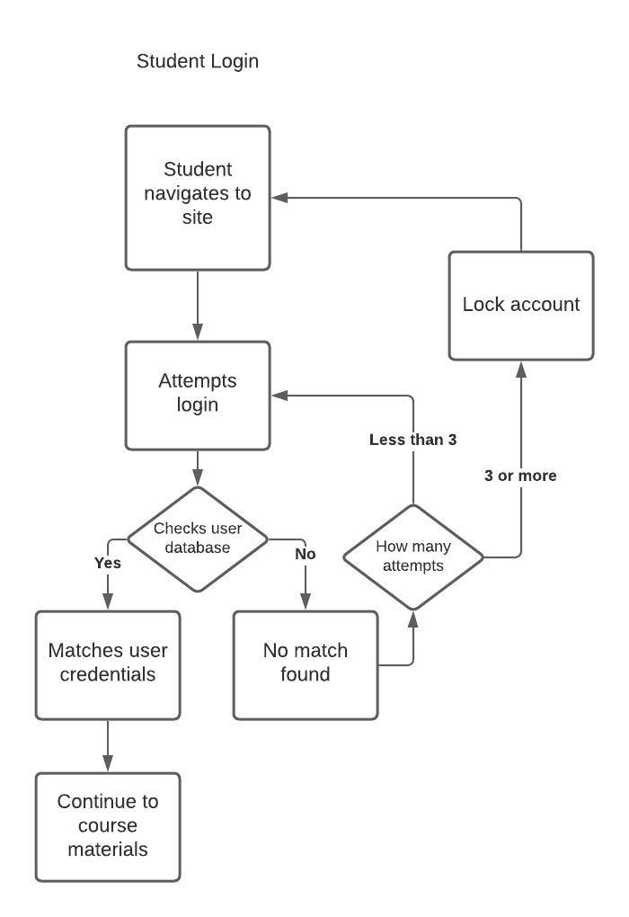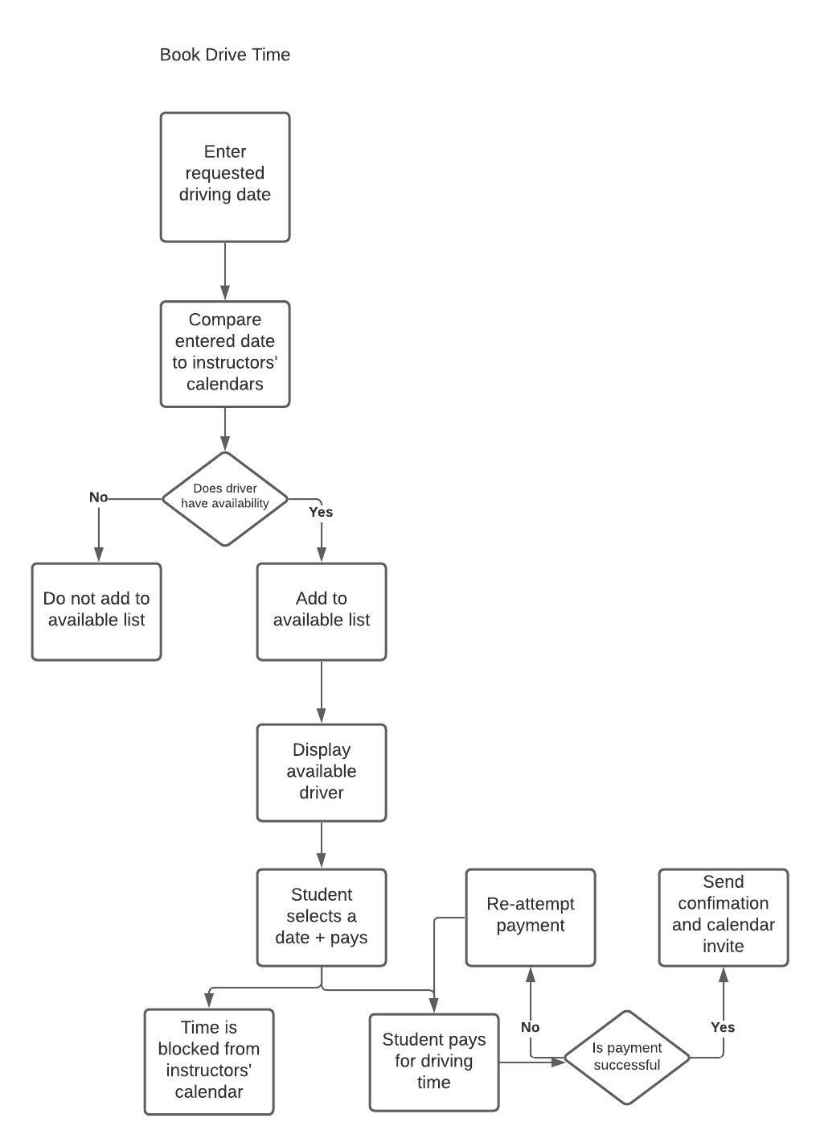

### UML Sequence Diagram

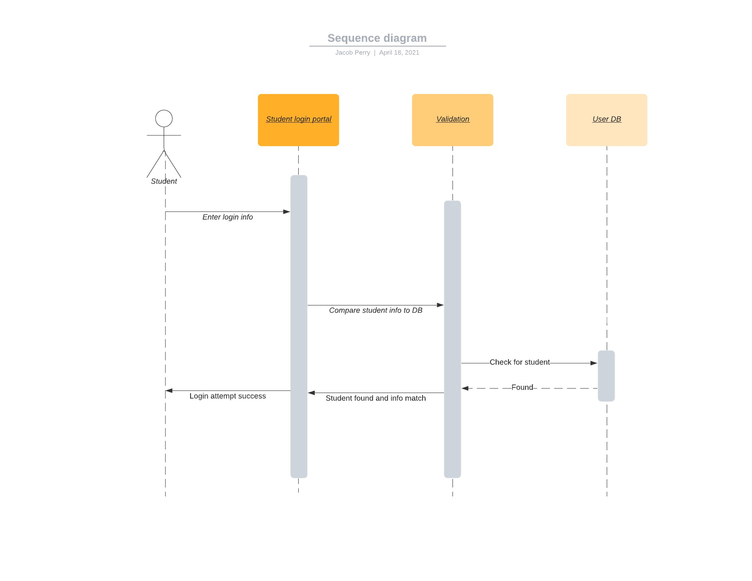

### UML Class Diagram

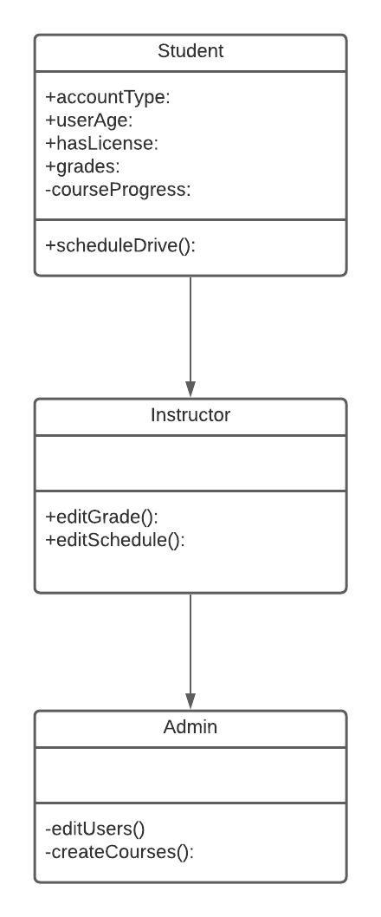

## Technical Requirements

*It is my opinion that based upon the requirements listed in the above diagrams, utilizing a cloud based host with strong integration with a preexisting platform like Google Suite or Office365 would work best. The company is looking to remain small and nimble but allow for pretty great flexibility for their users. Using a cloud based server with a site like DriverPass that has generally low storage requirements and needs to be always up for students to access materials for study is a perfect fit. Additionally, utilizing a preexisting suite of office tools instead of building from the ground up will offer more flexibility and a faster launch window while leaving the option open to develop proprietary software down the road.*